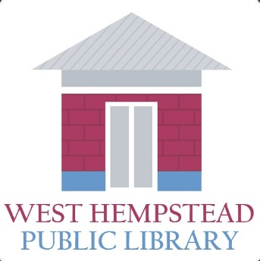
500 Hempstead Ave
West Hempstead, NY 11552
516 481 6591
www.whplibrary.org

The West Hempstead Public Library has a position available for a PT Page in the Adult/Reference area.

Hours of work are:
Monday 5 – 9 pm
Tuesday 5 – 9 pm
Thursday 5 - 9 pm
Friday 2 – 6 pm
and Sundays 12 noon – 5:00 pm
on a rotating/as needed basis.

Please email Emily Trezza etrezza@whplibrary.org
if interested in this position.

Salary is $18.85 per hour. Sunday pay is a time and one half. Must be a Nassau County resident.

